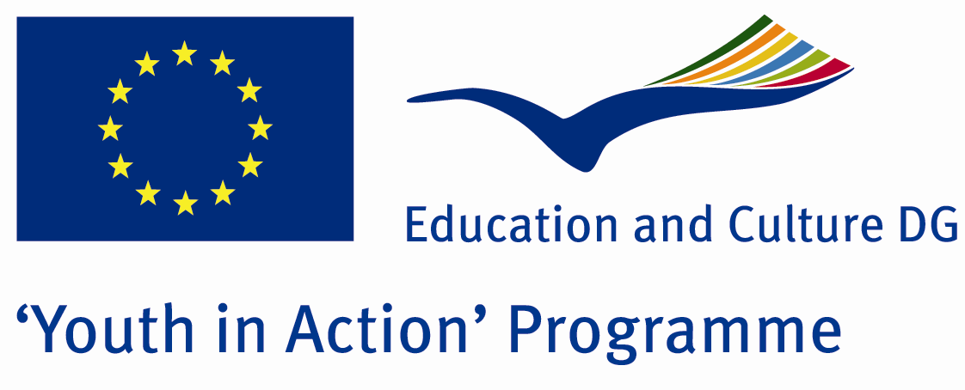

Hunger and Misery



ACTION 4.3 – Training And Networking

15-21th July 2011

Bartın/TURKEY

Please contact directly to;

adventurerpeacepigeons@gmail.com

Project Summary;
Every day around 24,000 people die directly from hunger or hunger related diseases in todays world especially in Africa..do you know how many people arent eating anthing during days.? Do you know how many people are changing his cars only because of one line.There are both multi milioners and starving people almost every country .
Why hunger is occuring ? There are some reasons such as natural ,economic and social. We want to attract attention for these problems.Our main goal is to find a solution and help starving people.Let’s do something for them.

Project Title; Hunger and Misery

Date and Venue; 15-21th July 2011 Bartın/TURKEY

Target Group; Non profit/non governmental organization, Public body, Body active at European level in the field of youth (ENGO), Informal group of young people, e.t.c…

Participants; 5 people from each country (18 - 25). Totally 8 countries.

Conditions; Accommodation, board and programme costs will be financed through European Commission Youth in Action Programme (Action 4.3). Travel costs will be reimbursed in 70% (APEX Tarrifs). Organizations from all 27 EU member countries plus Liechtenstein , Norway and Iceland are eligible to take part.

Working language: English

Organizer; Discovery And Adventure Group

How to apply: If you are interested, please send your Part III forms to
0090 216 483 21 67 by FAX please. (Fulfilled Part III which you can find in the attachment, of course signed and stamped) ..

Note: jpeg is not allowed..please send by fax…

Next step 2;
Original send via regular post to this address please:

Ertan DERİN
Öner İnşaat
Abdulhalik Renda Cd.
Parlar Sk. No:4 Pendik/İSTANBUL

If you have any questions you may contact with: adventurerpeacepigeons@gmail.com

Deadline for application; until 20th January 2011.

For Further information:
Contact Person
Ertan DERİN
Öner İnşaat
Abdulhalik Renda Cd.
Parlar Sk. No:4 Pendik/İSTANBUL

e-mail : adventurerpeacepigeons@gmail.com
Mobile : 0090 542 393 93 90
Fax : 0090 216 483 21 67

